User guide

Customer Login

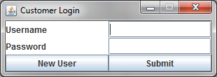

If the user is a has no account click the New User Button.

After the button is click a new GUI will open.

This is the register GUI which you will input your desired

username and password.

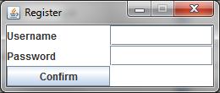

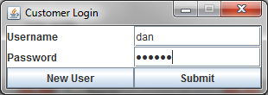Once registered the user can go back to the Customer Login GUI and input their username and password as show on the right. Once the username and password have been entered click the submit button.

If successful the Account GUI should open as shown below. The user will then have the option to either order food, update their profile, change their password or view previous orders.

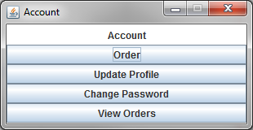

If the user chooses to order food the starters GUI should open. The user can then choose the meal they want by clicking the buttons. Click the next button to go onto the Mains GUI.

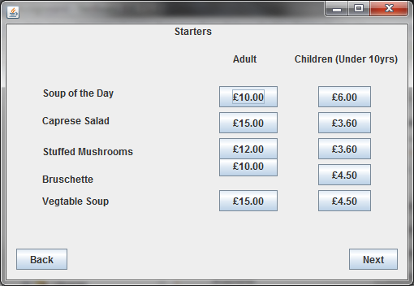

The user can The user can then choose the meal they want by clicking the buttons. Click the next button to finish ordering.

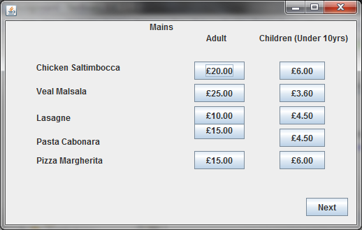

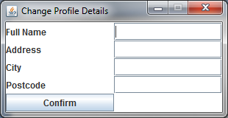If the user chooses to create or update their profile the Update Profile GUI should open. The user can then input their full name, address, city and postcode. Click the confirm button to go back to the Account GUI.

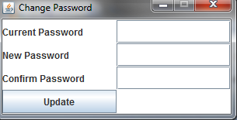

If the user chooses to change their password the Change Password GUI should open. The user can then input their current password their desired new pass word and confirm their new password. Click the update button to go back to the Account GUI.

Staff Login

If the user is a staff member their account will already have been created. Input the Username and Password and click the Submit button